**Solution Brief RKE2 Cluster deployment**

RKE2 Cluster deployment with Rancher Manager and Longhorn

Step by Step guide

Contents

Introduction 4

What is Rancher?4

What is RKE2? 4

What is Longhorn? .............................................................................................................................................................5

Architecture: 5

Prerequisites: 5

Air Gap Install 5

Specifications for Host Machine We Used: 5

RKE2 Installation 5

Rancher Manager 6

RKE2 HA Deployment 9

Longhorn Deployment…………………………………………………………………………………………………………………10

Figure 1 – *Required packages for airgap install* 6

Figure 2- *Enabling rke2-server.service* 6

Figure 3 – *Adding helm repo for rancher* 6

Figure 4 - Creating namespace cattle-system 6

Figure 5 – Creating deployment for cert-manager 7

Figure 6 - Installing cert-manager 7

Figure 7 - Installing rancher server 8

Figure 8 – Pods in cattle-system namespace....………………………………………………………………………………………..……………..……….8

Figure 9 – Dashboard (Rancher UI)…………….………………………………………………………………………………………………..…...9

Figure 10 – config.yaml in first node 9

Figure 11 - Air gap install on first node……………………………………………………………………………………………………………...10

Figure 12 - Config file in other two server nodes…………………………………………………………………………………………………..10

Figure 13 - HA nodes in RKE2 10

Figure 14 - Longhorn deployments. 11

Figure 15 - Services along with Longhorn UI(longhorn-frontend)………………………………………………………………………………. 11

# Introduction

## 

## What is Rancher?

Rancher is a platform to provision and manage Kubernetes Clusters. One can import existing clusters or deploy new clusters through cloud providers or local environment. It has its own GUI launched through rancher manager which has the options of creating k3s, RKE or RKE2 clusters.

## What is RKE2?

### RKE2 (also called RKE Government) is a CNCF certified Kubernetes distribution which focusses on security and compliance within US Federal Government Sector. In brief, it can be defined as a combination of k3s, RKE and security measures taken. It doesn’t rely on docker.

**What is Longhorn?**

Longhorn is a lightweight and easy-to-use distributed block storage system for Kubernetes. It comes with a standalone UI, and can be installed using Helm, kubectl, or the Rancher app catalog.

It divides a large block storage controller into a number of smaller storage controllers so that one storage controller per volume can be used. Longhorn turns each volume into a microservice. The controller is called the Longhorn Engine.

It has its own UI. The Longhorn UI interacts with the Longhorn Manager through the Longhorn API, and acts as a complement of Kubernetes. One can manage snapshots, backups, nodes and disks.

## Architecture:

### Prerequisites:

## Unique hostname for each node.

1. Supported OS are:

|  |  |
| --- | --- |
| DISTRO | VERSION |
| Ubuntu | 18.04, 20.04, 22.04 |
| CentOS | 7.8 |
| Rocky/RHEL | 8.5, 9.0 |
| SLES | 15 SP3, SP4 |
| SLE Micro | 5.1, 5.2, 5.3 |

1. Hardware:
   1. Minimum 4 GB RAM and 2 vCPUs.
   2. Recommended 8 GB RAM and 4 vCPUs.

## Networking:

Port 6443 and 9345 should be accessible by other nodes in the cluster.

## Air Gap Install

### Specifications for Host Machine We Used:

* CPU: 8 vCPUs
* Memory: 16 GB
* Storage: 160 GB
* OS: Ubuntu 22.04

## RKE2 Installation

Step 1: Download the  install script, rke2, rke2-images, and sha256sum archives from the release

* 1. mkdir /root/rke2-artifacts && cd /root/rke2-artifacts/
  2. curl -OLs <https://github.com/rancher/rke2/releases/download/v1.21.5%2Brke2r2/rke2->images.linux-amd64.tar.zst
  3. curl -OLs <https://github.com/rancher/rke2/releases/download/v1.21.5%2Brke2r2/rke2.linux->amd64.tar.gz
  4. curl -OLs <https://github.com/rancher/rke2/releases/download/v1.21.5%2Brke2r2/sha256sum->amd64.txt
  5. curl -sfL https://get.rke2.io --output install.sh



*Fig 1: Required packages for airgap install*

Step 2: Run the installation script by setting the path for the artifact

 INSTALL_RKE2_ARTIFACT_PATH=/root/rke2-artifacts sh install.sh

#### Step 3: Enable and start the rke2-server service

Systemctl enable rke2-server.service

Systemctl start rke2-server.service



*Fig 2: Enabling rke2-server.service*

**Rancher Manager**

Step 1: Run the following commands in sequence:

* 1. helm repo add rancher-latest <https://releases.rancher.com/server-charts/latest>



*Fig 3: Adding helm repo for rancher*

* 1. kubectl create namespace cattle-system



*Fig 4: Creating namespace cattle-system*

* 1. kubectl apply -f https://github.com/cert-manager/cert-manager/releases/download/v1.11.0/cert-manager.crds.yaml

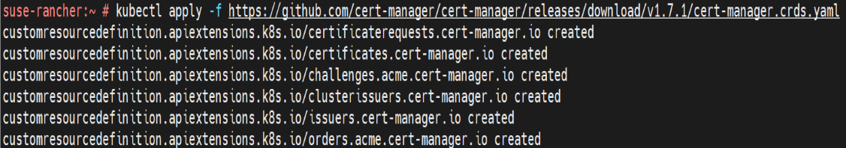

*Fig 5: Creating deployment for cert-manager*

* 1. helm repo add jetstack https://charts.jetstack.io
  2. helm repo update

1.6. helm install cert-manager jetstack/cert-manager \

--namespace cert-manager \

--create-namespace \

--version v1.11.0

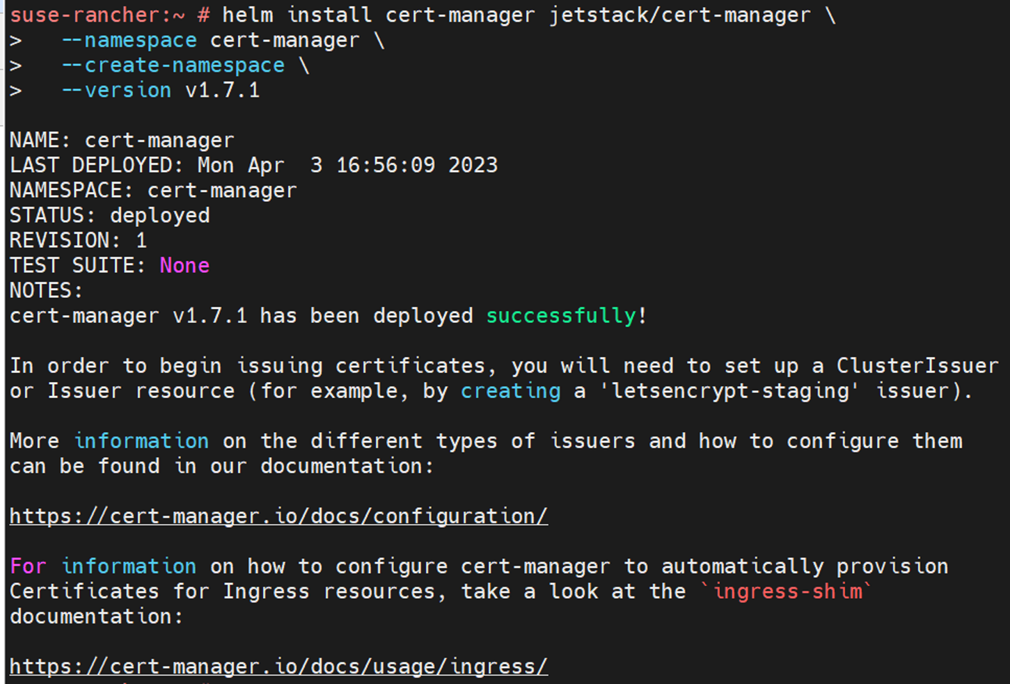

*Fig 6: Installing cert-manager*

Step 2: Run the below cmd to setup rancher manager dashboard

helm install rancher rancher-stable/rancher --namespace cattle-system --set hostname=(hostname provided by instructor) --set replicas=1 --set bootstrapPassword=( provided by instructor)

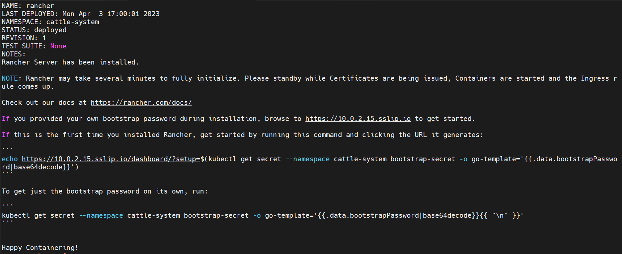

*Fig 7: Installing rancher server*

Step 3: Verify the status of the rancher server deployed

kubectl -n cattle-system rollout status deploy/rancher

kubectl get pods -n cattle-system

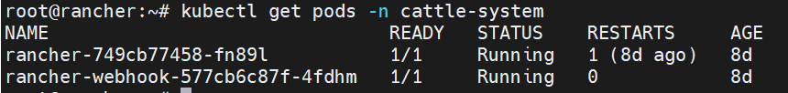

*Fig 8:* *Pods in cattle-system namespace*

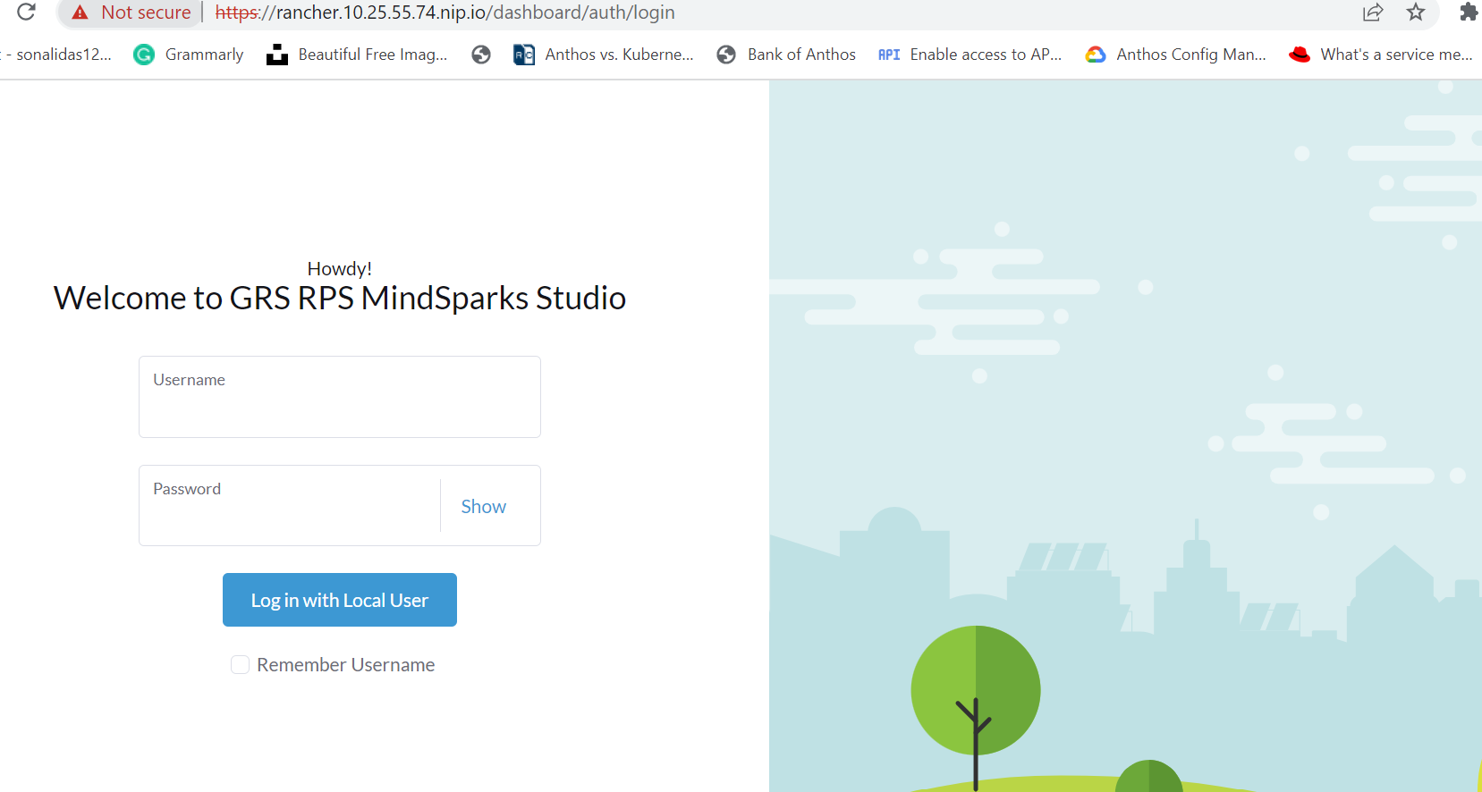

*Fig 9: Dashboard (Rancher UI)*

**RKE2 HA Deployment**

Step 1: Create a config file in yaml in /etc/rancher/rke2 directory

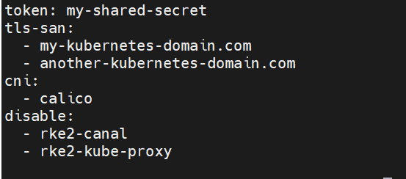

*Fig 10: config.yaml in first node*

Step 2: Repeat step 1 and 2 from RKE2 installation on first node



*Fig 11: Air gap install on first node*

Step 3: Create config file in other server nodes with token taken from first node

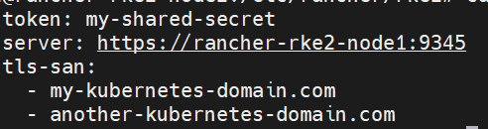

*Fig 12: Config file in other two server nodes*

Step 4: Run the installation script with the config file in other two nodes. Export the path of kubectl to /var/lib/rancher/rke2/bin/kubectl

Step 5: Run kubectl get nodes to check the status

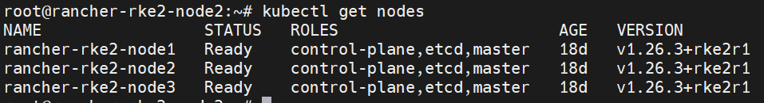

*Fig 13: HA nodes in RKE2*

**Longhorn deployment (through helm)**

Step 1: Checking requirements:

* 1. Container runtime compatible with Kubernetes
  2. Kubernetes >= v1.21

*kubectl version*

* 1. open-iscsi installed or not

kubectl get pod | grep longhorn-iscsi-installation

If not, then it can be installed using below command:

*kubectl apply -f* [*https://raw.githubusercontent.com/longhorn/longhorn/v1.4.1/deploy/prerequisite/longhorn-iscsi-installation.yaml*](https://raw.githubusercontent.com/longhorn/longhorn/v1.4.1/deploy/prerequisite/longhorn-iscsi-installation.yaml)

* 1. NFSv4 client present or not

If not, then can be installed using below command:

*apt-get install nfs-common*

Step 2: Adding the longhorn helm repo

helm repo add longhorn <https://charts.longhorn.io>

helm repo update

Step 3: Instaling longhorn through helm

helm install longhorn longhorn/longhorn --namespace longhorn-system --create-namespace

Step 4: Check the status

kubectl -n longhorn-system get pod or deployments

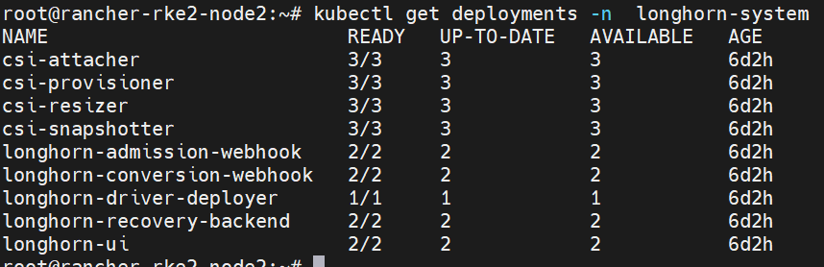

*Fig 14: Longhorn deployments*

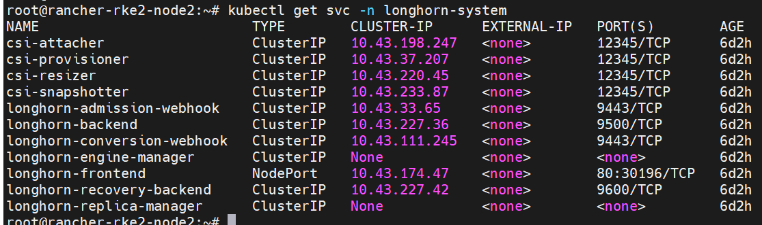

*Fig 15: Services along with Longhorn UI(longhorn-frontend)*